Activity 1 - What does it do?

1. **Lesson Objective 2**: Understand how to use csv files in a program using csv reader

**Instructions**: Use the comments (below) to explain each section of code in TempByMonth.py. Write the comment number in the box next to the matching line(s) of code. The first one has been done for you.

**Support:** Use source code and investigate the code.

|  |  |  |
| --- | --- | --- |
| Code | | Original csv file |
| TempByMonth_wdid.py | | TempByMonth.csv  January,5,8,6,6  Feburary,5,9,7,6  March,6,12,9,8  April,7,15,11,9  May,10,18,15,14  June,13,21,20,18  July,15,23,18,22  August,15,23,22,16  September,13,20,14,18  October,10,16,16,9  November,7,12,3,9  December,5,9,2,6 |
| Comment No. |  |
| 4 | import csv |
| 1 | f = open('TempByMonth.csv') |
| 6 | csv_f = csv.reader(f) |
| 2 | newlist = [] |
| 5 | for row in csv_f: |
| 8 | row[1] = int(row[1])  row[2] = int(row[2])  row[3] = int(row[3])  row[4] = int(row[4]) |
| 7 | newlist.append(row[0:5]) |
| 3 | print(newlist) |

# Comments

1. ~~# Open the TempByMonth file and stores it in a variable [f]ile~~
2. ~~# Create an empty list to store the data from the file.~~
3. ~~# Print out the new data structure~~
4. ~~# Import csv module~~
5. ~~# Iterating through the csv data~~
6. ~~# csv_f will allow us to iterate over the given .csv file i.e. read the data~~
7. ~~# adding each row to the newlist - [0:5] the range of items on each row~~
8. ~~# Convert the string values into integers~~

**Extension questions**:

1. What data structure does csv reader return for each row?
2. Using just the first two months, write down the contents of newlist.
3. Justify the use of the csv module in this case.

Activity 2 Additional list functions

1. **Lesson Objective 3:** Use additional list methods to manipulate the data

For all tasks show the code and screen shot of sample run.

# Task1

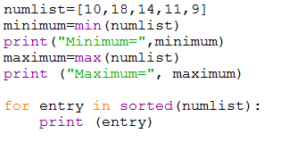Write this code as a new program. Explain what it does.

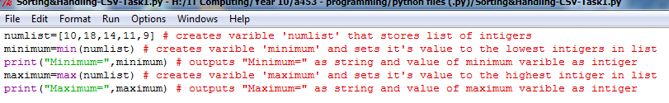(You should be able to work this out by just looking at it!)

# Task 2

Repeat the above code, replacing numlist with the following list:

**Scores=[[“Hugh”,23],[“Pugh”,45],[“Barney”,76],[“MaGrue”,42]]**

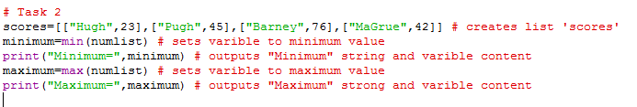Explain the results

# Task 3

Look at the code below: Write this program. Explain the results and answer the comment questions

*Use the scores.csv file to replace the first line (a fixed list) and use the csv methods to create the list. Use the supervillains example as a guide.*

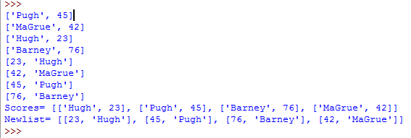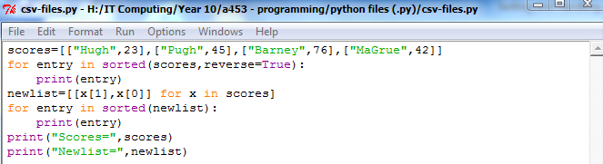

Activity 3: Be able to analyse and correct csv reader code

**Instructions**

Working with your programming partner:

1. Open the .py file shown on the board
2. In addition to creating a data structure from a csv file, the code works out the minimum temperature reading and appends it to the month’s list. It also sorts and displays the data by lowest temperature.
3. There are three errors in the code – your task is to find and fix them.

Error 1:

Error 2:

Error 3: